Project Name |  | Confidentiality Level
DBMS Project |  | For Recipients’ Reference Only
Project ID | Version | Document Code
BP | 1.0 | Project ID_SD_001

DBMS Software System Design Specification

Member: 张瑜 15301024
杜月锌 15301033



Copyright © Ruankosoft Technologies(Shenzhen), Co., Ltd.
. All Rights Reserved
Revision Record
Date | Revision Version | CR ID /Defect ID | Sec No. | Change Description | Author
2017.5.1 | 1.0 |  |  | Start design | 15301024

Content
1 Introduction 8
1.1 Purpose 8
1.2 Scope 8
1.2.1 Name 8
1.2.2 Functions 8
1.2.3 Applications 8
2 Level 0 Design Description 8
2.1 Software System Context Definition 8
2.2 Design Considerations 9
2.2.1 Design Alternatives 9
2.2.2 Design Constraints 10
2.2.3 Other Design Considerations 10
3 Level 1 Design Description 10
3.1 System Architecture 10
3.1.1 Description of the Architecture 10
3.1.2 Representation of the Business Flow 10
3.2 Decomposition Description 12
3.2.1 Module/Subsystem 1 Description 12
3.2.2 Table Management 12
3.2.3 Field Management 12
3.2.4 Data Management 13
3.3 Dependency Description 13
4 Level 2 Design Description (Optional) 13
4.1 Create database 14
4.1.1 Design Description 14
4.1.2 Function Illustration 15
4.2 Create Table 15
4.2.1 Design Description 15
4.2.2 Function Illustration 16
4.3 Add field 17
4.3.1 Design Description 17
4.3.2 Function Illustration 18
4.4 Data management 18
4.4.1 Insert records 18
4.4.2 Query log 20
5 Data Structure/Database Design 21
5.1 Data Type 21
5.2 Integrity 21
5.2.1 Entity Integrity 21
5.2.2 Referential Integrity 22
5.2.3 User-defined Integrity 22
5.3 Database file 22
5.4 Database Description File 23
5.4.1 File Name 23
5.4.2 File Structuree 23
5.4.3 Database Information Structure 23
5.5 Table Description File 23
5.5.1 File Name 23
5.5.2 File Structure 23
5.5.3 Table Information Structure 23
5.6 Table Definition File 24
5.6.1 File Name 24
5.6.2 File Structure 24
5.6.3 Field Information Structure 24
5.7 Record File 24
5.7.1 File Name 24
5.7.2 File Strcuture 24
5.7.3 Record Information Structure 24
5.8 Integrity Description File 24
5.8.1 File Name 24
5.8.2 File Structure 25
5.8.3 File Information Structure 25
5.9 Index Description File 25
5.9.1 File Name 25
5.9.2 File Structure 25
5.9.3 Index Information Structure 25
5.9.4 Index data file 25
6 UI Design 25
6.1 Main Interface 25
6.2 Show Table Structure Interface 26
6.3 Select Record Interface 26
6.4 Crate Table Interface 27
6.5 Add Field Interface 27
6.6 Insert Record Interface 27
7 Detailed Design of Module 28
7.1 Class1 Design 28
7.1.1 Overview 28
7.1.2 Class Diagram 28
7.1.3 Attributes 28
7.1.4 Methods 28
7.2 Class2 Design 29

Keywords:
DBMS .RDBMS .MFC .SDI .Dialog .C/S structure .MVC .integrity .
database .table .field .record. two File system.
Abstract:
This system is the first version of the database management system, including the creation of the database, the management of the database table, add and query records, etc.. This document describes the design of each functional module, so that software developers can better analyze and design software, but also to facilitate the customer to make a better opinion.
List of abbreviations:
Abbreviations | Full spelling | Chinese explanation
MFC | Microsoft Foundation Classes | 微软基础类库
MFC SDI | Single Document Interface | 单文档界面
DBMS | Database Management System | 数据库管理系统
RDBMS | Relational Database Management  System | 关系型数据库管理系统
MVC | Model View Controller | 模型(model)－视图(view)－控制  器(controller)

- Introduction

Purpose
This document describes the Database Management System's design process, including general design and detailed design, in order to conduct project team to implement coding and unit testing. Expected reader of this specification is intermediate users (refers to project team member, client representative, testing staff, QA and etc.).

Scope
    - Name
Database Management System.
    - Functions
Software functions please refer to the requirements specification document: requirement analysis of Database Management System.
    - Applications
This system is the relational database management system, the data storage uses the document, for the small database system. Small data storage and query for small amount of data.
- Level 0 Design Description

Software System Context Definition
Database management system (DBMS) architecture includes: DBMS architecture, user interface, syntax analysis, query processing, directory management, concurrency control, recovery mechanism, physical storage management, etc.. This system mainly realizes the function of DDL, DML, DQL and so on in the simulation DBMS.

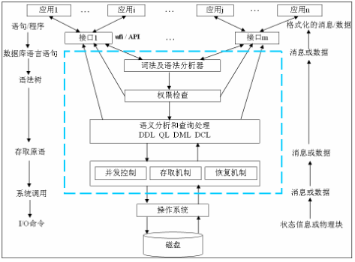

The system program structure as shown in the following figure:
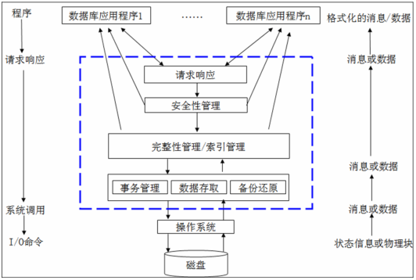
Figure 2-1 Database management system structure diagram

Design Considerations
    - Design Alternatives
1. Program structure design
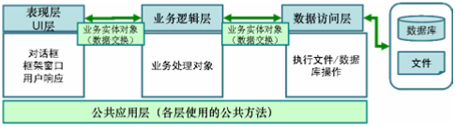
Based on the logic responsibility, the program software structure can be divided into 3 layers: presentation layer, business logic layer and data access layer. Data in each layer is transferred by “entity class” (data object). Besides, public class that irrelative with business may be used in layers in the program as the "Tool class."

2. Data Storage Structure
The system stores data with the binary file of the operating system, and saves the definition data and data information with the folder and file. DBMS system definition files include the database description file (ruanko.db), table description file (*.tb), table definition file (saves field information, *.tdf), index description file (*.tid), integrity description file (*.tic). The data files of DBMS include the record file (*.trd), index data file (*.ix), log file (*.log), transaction data file (*.tac), temporary file (*.tmp), etc.
The relation diagram between the database description file, table description file, table definition file and record file is as follows:
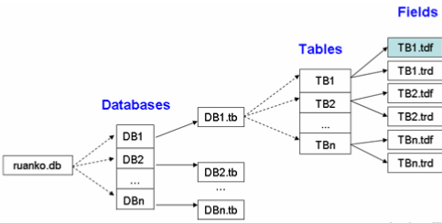

    - Design Constraints
      - Standards compliance
Could expand the specifications that do not exist in the following requirements, but it cannot contrary to the standard. It follows: <COE technical requirement standard of Ruanko Lab>, <COE programming standard requirement of Ruanko Lab>.
      - Technology Limitations
Parallel operation: Allow multiple games running at the same time, and can ensure the correctness and completeness of the data.
Coding standard: COE programming standard requirement of Ruanko Lab
    - Other Design Considerations
The minimum configuration of the hardware:
CPU: 1GHZ
RAM: 128MB
To ensure that the game can run smoothly, the configuration best meet the following requirements:
CPU: 1.8GHZ
RAM: 1G
- Level 1 Design Description

System Architecture
    - Description of the Architecture
The system is developed according to the thought of “divide and rule”. The functions are divided into many modules to manage and develop individually.

    - Representation of the Business Flow
The detailed module division of the system is shown below:
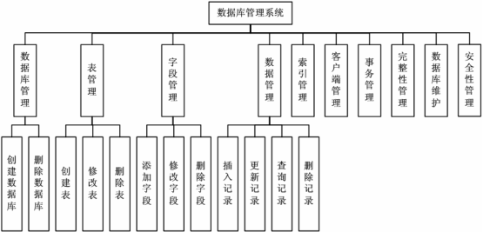
Figure 3-1 Database management system function structure diagram

Modules are divided according to three-layer structure and shown below:
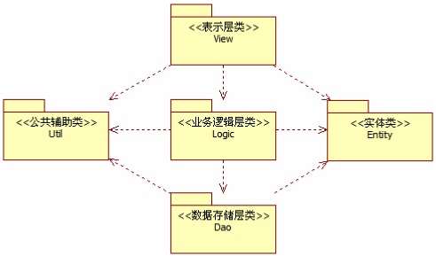
Figure 3-2Program structure diagram

1. Project Structure
This system is divided into two main parts of the database server project and database enterprise manager. The client is a SDI project. The server is a dialog project.
The project name of the client is RKDBMS.
The project structure is shown below:
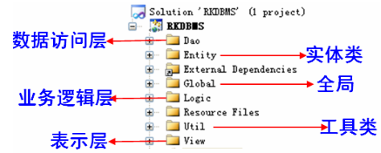
Figure 3-3 Client project structure diagram
2. Project program structure
Make logic to program by VS2013 Solution Explorer through Filter.
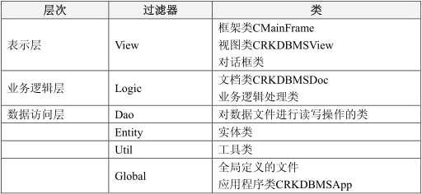

Decomposition Description
    - Module/Subsystem 1 Description
- Overview
Create and delete the database. Implement database definition file creation, modification Published by Ruanko COE–Technical Document Page 10 of 25 Copyright © Ruankosoft Technologies Co., Ltd. and query.
- Functions
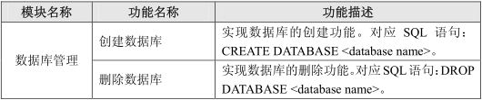
    - Table Management
1. Overview
Finish the functions of table creation, modification and deletion. Implement the table description file creation and update.
2. Functions
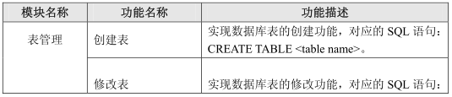
    - Field Management
1. Overview
Finish the functions of table field additon, modification and deletion. Implement table field definition file creation, modification and query.
2. Functions
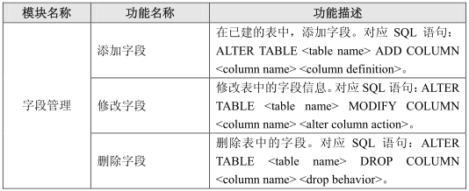
    - Data Management
1. Overview
Implement the functions of data storage, update, modification and query.
2. Functions
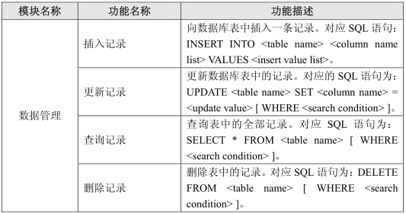

Dependency Description
This project is a Windows window program and depends on the operating system. The data storage depends on the file management system of the operating system. The communication between the server and client depends on TCP/IP network communication protocol.
- Level 2 Design Description (Optional)

Create database
    - Design Description
Class and class diagrams are as follows:
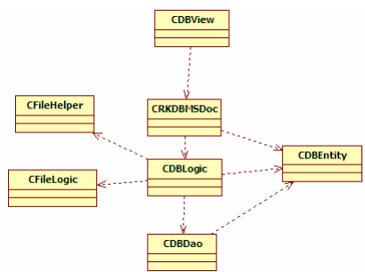
      - CDBView
(1) Overview
Display database structure view class, in the tree view shows the database name.

(2) Definition (Optional)
      - CRKDBMSDoc
(1) Overview
Document class, set the default database name, store and read data, control interface display and
(2) Definition (Optional)
      - CDBLogic
(1) Overview
Database business logic class, to determine whether the default database exists, if not exist to create the default database.
(2) Definition (Optional)
      - CDBDao
(1) Overview
Database information operation class, the database description information in binary format to save the "Ruanko.db" file.
(2) Definition (Optional)
      - CFileLogic
(1) Overview
According to the database name, the absolute path of the database description file.
(2) Definition (Optional)
      - CFileHleper
(1) Overview
According to the database name, the absolute path of the database description file.
(2) Definition (Optional)

    - Function Illustration
The system creates a database called "Ruanko" by default. The basic information of the database is saved in CDBEntity, using the tree view CDBView display the database name. Through the document class CRKDBMSDoc, the database information is passed to the view class. Database information passed to the CDBLogic class CRKDBMSDoc class, CDBLogic class will be passed to the CDBDao database information class, CDBDao class will be stored in the database information "Ruanko.db" file.

Create Table
Create a database table description file Ruanko.tb based on the database name Ruanko to save the table information in the database. The table structure description file (*.tdf) and the data record file (*.trd) can be found by reading the table description file (Ruanko.db).

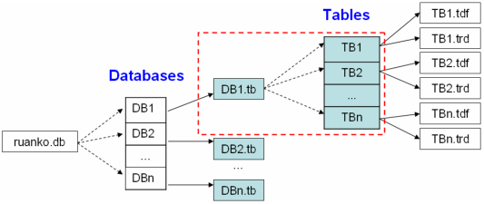
    - Design Description
Class and class diagrams are as follows:
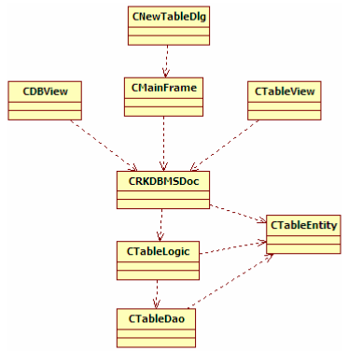
      - CMainFrame
Frame window class, display view, the response to create table menu events.
      - CNewTableDlg
New table dialog class, through the control map to obtain the input table name.
      - CDBView
Display database structure view class, in the tree view of the database node under the table name.
      - CTableView
Show table structure view class. Display table structure using list controls.
      - CRKDBMSDoc
Document class, store database and table information, and control interface display and update.
      - CTableLogic
Table business logic class.
      - CTableDao
Table file operation class, the table information in binary format to save the file.

    - Function Illustration
The database information is saved by CDBEntity, table information is saved by CTableEntity. Create a table dialog box by creating a table menu event in response to the CMainFrame class. Get table name by creating table CNewTableDlg. Pass the input table name to CRKDBMSDoc. CRKDBMSDoc passes the database name and table information to CTableLogic. CTableLogic passes table file path and table information to CTableDao. CTableDao saves table information in binary format to file. After the save is successful, the table name is displayed in CDBView, and the table structure is displayed in CTableView.

Add field
Create a table definition file (*.tdf) based on the table name and save the user-defined table structure. To save the file path to the table description file, the table definition file (*.tdf) can be found by reading the table description file. Save field information to the table definition file.
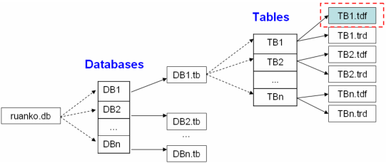
    - Design Description
Class and class diagrams are as follows:
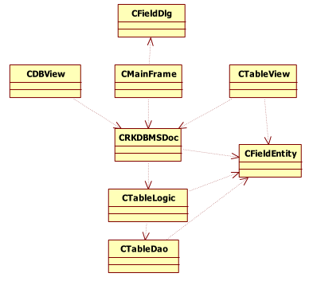
      - CFieldDlg
Add Field dialog class to receive input field information.
      - CMainFrame
Frame window class, response to add field events.
      - CRKDBMSDoc
Document class, save database information, table information and field information, and control interface display and update.
      - CDBView
Database view class, display the database table name and the field name in the table.
      - CTableView
Table structure view class to display the field information in the selected table.
      - CTableLogic
Table business logic class, call the CTableDao class method, the field information is saved to the table definition file (*.tdf), and modify the table description file (*.tb).
      - CTableDao
Table database processing class, the field information stored in the table definition file.
      - CFieldEntity
Field information entity class.

    - Function Illustration
CMainFrame class response to add field events, the user selects the table in CDBView, in the CFieldDlg to receive the input field information, field information stored in CFieldEntity. CRKDBMSDoc passes the database name, table, and field to CTableLogic. CTableLogic saves the field information to the table definition file. CDBView field names shown in table node node under the CTableView Liezi display field information.

Data management
Data management module is divided into insert records and query records.

    - Insert records
Table description file "Ruanko.tb" to save the table a variety of file paths: *.tdf file to save the table definition information, *.trd file used to save the record data. When you insert a record, the record data is stored in the file in the table definition file (*.tdf).
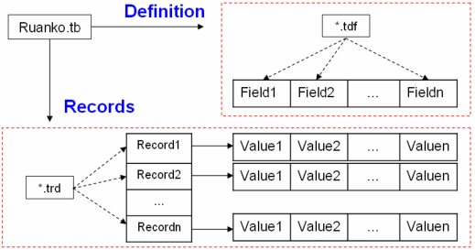
Class and class diagrams are as follows:
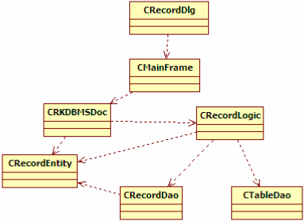

      - CRecordDlg
Add a record dialog class, receive the input record information.
      - CMainFrame
Frame window class, in response to add record events.
      - CRKDBMSDoc
Document class, save database information, table information and record information, and control interface display and update.
      - CRecordLogic
To record the information business logic class, call the CRecordDao class method to save the record information to the table record file (*.trd), and call the CTableDao class method to update the table description information.
      - CRecordDao
Record the information data operation class, save the record information to the table record file.
      - CTableDao
Table information operation class, update table description information.
      - CRecordEntity
Record information entity class.
      - Function Illustration
In the CMainFrame class response to insert the record message response function, in the CRecordDlg dialog box to display the field in the table, edit the value of the field, assembled into a record information stored in CRecordEntity. And passed to CRKDBMSDoc, CRKDBMSDoc database name, table and field information passed to CRecordLogic. CRecordLogic passes the record information to CRecordDao and calls the CTableDao class method to update the table description letter. The CRecordDao class stores the record information in the record data file.

    - Query log
When querying records, first read the table definition file (*.tdf) query table structure, and then read the data in the record file (*.trd) according to the table structure, return to the logical layer.
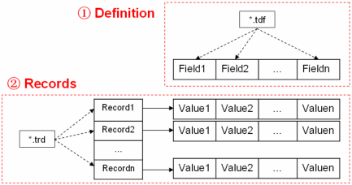

Class and class diagrams are as follows:
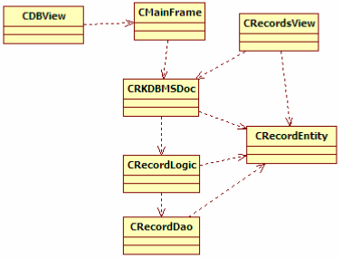
      - CMainFrame
Frame window class, responding to query logging operations.
      - CRKDBMSDoc
Document class, save database information, table information and record information, and control interface display and update
      - CDBView
Database view class, display the database table name and field name.
      - CRecordsView
Record view class, display the record information in the table.
      - CRecordLogic
Record information business logic class, call the CRecordDao method to obtain the record information.
      - CRecordDao
Record information data operation class, read the record file (.Trd), access to records in the file information.
      - CRecordEntity
Record information entity class.
      - Function Illustration
Using CMainFrame class response time, get the selected table in CDBView. CRKDBMSDoc passes the current table information to CRecordLogic, CRecordLogic passes table information to the CRecordDao class. CRecordDao read the "*.trd" file, access to the record information, and return to the logical class through the CReocrdEntity array. Finally, record information is displayed in CecordsView.

- Data Structure/Database Design
5.1 Data Type
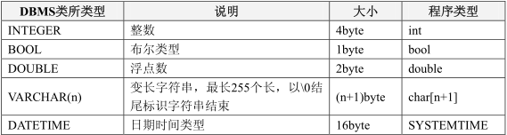
5.2 Integrity
5.2.1 Entity Integrity
PRIMARY KEY
5.2.2 Referential Integrity
FOREUGN KEY
5.2.3 User-defined Integrity
1. CHECK
2. UNIQUE
3. NOT NULL
4. DEFAULT
5. IDENTITY
5.3 Database file
Convention: DBMS_ROOT root for DBMS program installation. All data in this database, data stored in binary file.

1. database description file
When creating a database, create a folder named after the database in the [DBMS_ROOT]/data folder. For example, the database name is Ruanko, then create the [DBMS_ROOT]/data/Ruanko folder.

2. database (1 folder +2 file)
(1) database folder
When creating a database, create a database named in the [DBMS_ROOT]/data folder Clip. For example, the database name is Ruanko, then create the [DBMS_ROOT]/data/Ruanko folder.
(2) table description file
In the created database folder, create a file with the same name as the database, suffix tb. In database Ruanko, create [DBMS_ROOT]/data/Ruanko/Ruanko. TB file.
(3) log file
In the created database folder, create a file with the same name as the database, suffix log. In database Ruanko, create database data folder]/Ruanko. Log file.
Default path: [DBMS_ROOT]/data/Ruanko.

3. table (4 files)
When a table is created, the file is used to save the table information.
(1) table definition file
In the database folder, create a file with the same name as the table name, suffix tdf. Such as: create a Account table in database Ruanko, then create: [DBMS_ROOT]/data/Ruanko/Account. TDF file.
(2) record file
In the database folder, create a file with the same name as the table name, suffix trd. For example: create a Account table in database Ruanko, then create: [database data folder]/Account. TRD file.
Default path: [DBMS_ROOT]/data/Ruanko.
(3) integrity description file
In the database folder, create a file with the same name as the table name, suffix tic. Such as: create a Account table in database Ruanko, then create: [DBMS_ROOT]/data/Ruanko/Account. Tic file.
(4) index description file
In the database folder, create a file with the same name as the table name, suffix tid. Such as: create a Account table in database Ruanko, then create: [DBMS_ROOT]/data/Ruanko/Account. TID file
5.4 Database Description File
5.4.1 File Name
ruanko.db
5.4.2 File Structuree
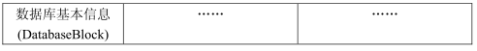
5.4.3 Database Information Structure
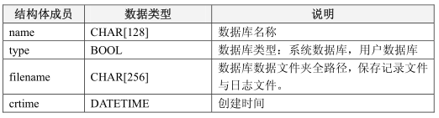
5.5 Table Description File
5.5.1 File Name
[Database_Name].tb
5.5.2 File Structure
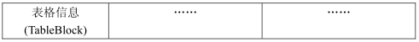
5.5.3 Table Information Structure
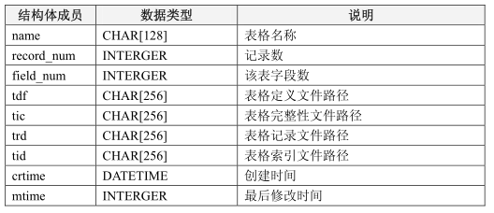

5.6 Table Definition File
5.6.1 File Name
[Table_Name].tdf
5.6.2 File Structure
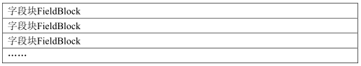
5.6.3 Field Information Structure
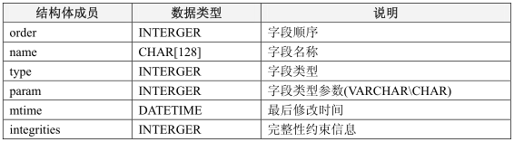
5.7 Record File
5.7.1 File Name
[Table_Name].trd
5.7.2 File Strcuture
5.7.3 Record Information Structure
1. In DBMS, a record store format by user-defined.
2. Based on the characteristics of data storage, all of the blocks and the field size are stored in the adjustment of a multiple of 4, in order to improve the efficiency of the data read.
5.8 Integrity Description File
5.8.1 File Name
[Table_name].tic

5.8.2 File Structure
5.8.3 File Information Structure
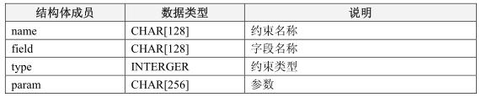
5.9 Index Description File
5.9.1 File Name
[Table_Name].tid
5.9.2 File Structure
5.9.3 Index Information Structure
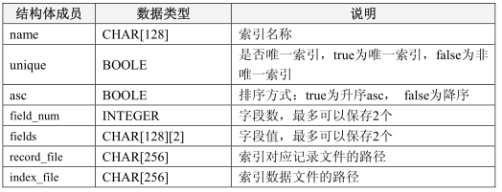
5.9.4 Index data file
File Name: [index_name].ix
Folder: Table folder
Index Name: [Field_Name]Index

- UI Design
6.1 Main Interface
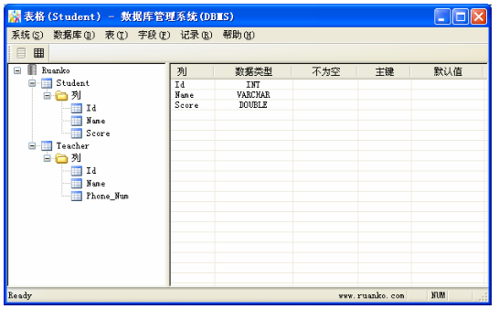
6.2 Show Table Structure Interface
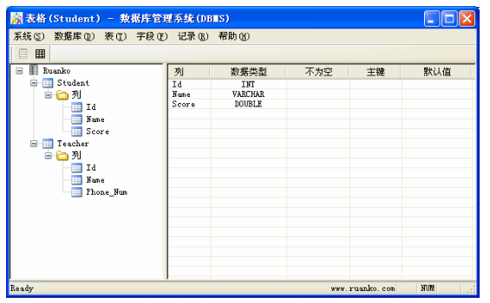
6.3 Select Record Interface
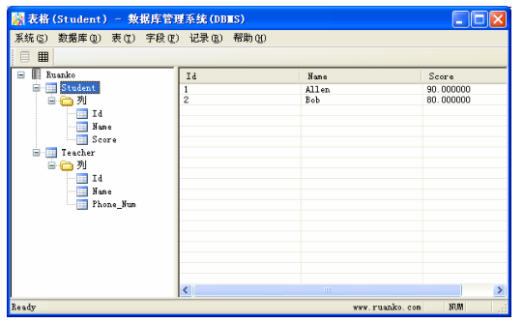
6.4 Crate Table Interface
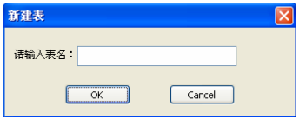
6.5 Add Field Interface
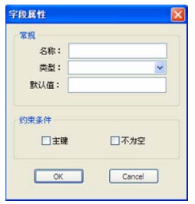
6.6 Insert Record Interface
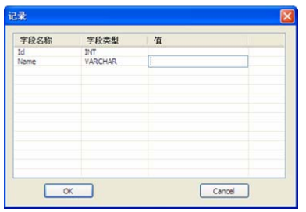
- Detailed Design of Module

Class1 Design
    - Overview
Recount the responsibilities and functions of the class. Sequence diagrams, collaboration diagrams, or state chart diagrams can be used to depict the realizations, if it’s not described previously. If necessary, the static and dynamic relationships with the related classes could also be described.
    - Class Diagram
Class diagram, if not described in HLD.
    - Attributes
The common data structure should be described here.
Visibility | Name | Type | Brief descriptions
    - Methods
Every method should be described.
      - Method1
(1) Method Descriptions
Prototype
Description
Calls
Called By
Input
Output
Return
Exception

(2) Implementation Descriptions
Pseudo codes could be used to depict the method definitions. This is the most important part of LLD.
      - Method2

Class2 Design

